**Write queries for the following**

1. Create the Customer table with the following columns.

CustomerId Number(5)

Cust_Name varchar2(20)

Address1 Varchar2(30)

Address2 Varchar2(30)

**create table Customer(CustomerId bigint,Cust_Name nvarchar(20),Address1 nvarchar(30),Address2 nVarchar(30));**

1. Modify the Customer table Cust_Name column of datatype with Varchar2(30), rename the column to CustomerName and it should not accept Nulls.

**EXEC SP_RENAME 'customer.Cust_Name','CustomerName','COLUMN';**

**ALTER TABLE Customer**

**ALTER COLUMN CustomerName VARCHAR(30) NOT NULL;**

1. Add the following Columns to the Customer table.

Gender Varchar2(1)

Age Number(3)

PhoneNo Number(10)

**ALTER TABLE Customer ADD Gender nvarchar(1),Age int,PhoneNo bigint;**

1. Add the below records to the Customer table:

(1000, ‘Allen’, ‘#115 Chicago’, ‘#115 Chicago’, ‘M’, ‘25, 7878776’)

1000, Allen, #115 Chicago, #115 Chicago, M, 25, 7878776

1001, George, #116 France, #116 France, M, 25, 434524

1002, Becker, #114 New York, #114 New York, M, 45, 431525

**insert customer values(1000, 'Allen', '#115 Chicago', '#115 Chicago', 'M', 25, 7878776);**

**insert customer values(1001, 'George', '#116 France', '#116 France', 'M', 25, 434524);**

**insert customer values(1002, 'Becker', '#114 New york', '#114 New york', 'M', 45, 431525);**

1. Add the Primary key constraint for Customerld with the name Custld_Prim.

**ALTER TABLE customer alter column customerId bigint not null;**

**ALTER table customer add constraint custId_prim primary key(customerId);**

1. a) Disable the constraint on CustomerId, and insert the following data:

1002, Becker, #114 New York, #114 New york , M, 45, 431525

1003, Nanapatekar, #115 India, #115 India , M, 45, 431525

b) Drop the constraint Custld_Prim on CustomerId and insert the following Data.

**ALTER TABLE customer drop constraint custId_prim;**

**insert customer values(1003,'Nanapatekar', '#115 India', '#115 India' , 'M', 45, 431525);**

1. Alter Customer table, drop constraint Custid_Prim.

1002, Becker, #114 New York, #114 New york , M, 45, 431525, 15000.50

1003, Nanapatekar, #115 India, #115 India , M, 45, 431525, 20000.50

1. Create Employee table with same structure as EMP table.

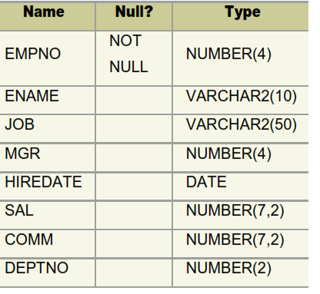

**CREATE TABLE EMP(EMPNO int not null,ENAME nvarchar(10),JOB nvarchar(50),MGR int,HIREDATE date,SAL NUMERIC(7,2),COMM NUMERIC(7,2),DEPTNO smallint);**

1. Insert the following data in the above table
2. Write a query to populate Employee table using EMP table’s empno, ename, sal,, deptno columns.

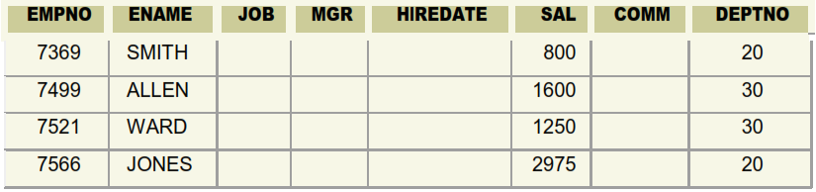

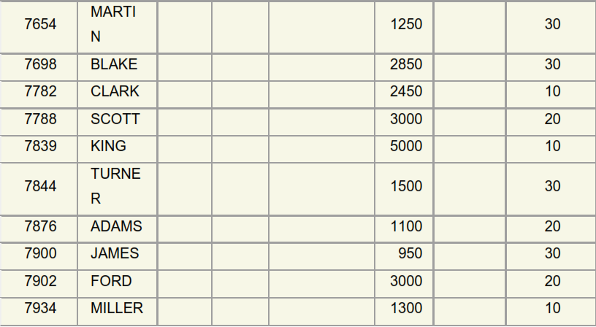

**insert EMP(EMPNO,ENAME,SAL,DEPTNO)values(7369,'SMITH',800,20);**

**insert EMP(EMPNO,ENAME,SAL,DEPTNO)values(7499,'ALLEN',1600,30);**

**insert EMP(EMPNO,ENAME,SAL,DEPTNO)values(7521,'WARD',1250,30);**

**insert EMP(EMPNO,ENAME,SAL,DEPTNO)values(7566,'JONES',2975,20);**

**insert EMP(EMPNO,ENAME,SAL,DEPTNO)values(7654,'MARTIN',1250,30);**

**insert EMP(EMPNO,ENAME,SAL,DEPTNO)values(7698,'BLAKE',2850,30);**

**insert EMP(EMPNO,ENAME,SAL,DEPTNO)values(7782,'CLARK',2450,10);**

**insert EMP(EMPNO,ENAME,SAL,DEPTNO)values(7788,'SCOTT',3000,20);**

**insert EMP(EMPNO,ENAME,SAL,DEPTNO)values(7839,'KING',5000,10);**

**insert EMP(EMPNO,ENAME,SAL,DEPTNO)values(7844,'TURNER',1500,30);**

**insert EMP(EMPNO,ENAME,SAL,DEPTNO)values(7876,'ADAMS',1100,20);**

**insert EMP(EMPNO,ENAME,SAL,DEPTNO)values(7900,'JAMES',950,30);**

**insert EMP(EMPNO,ENAME,SAL,DEPTNO)values(7902,'FORD',3000,20);**

**insert EMP(EMPNO,ENAME,SAL,DEPTNO)values(7934,'MILLER',1300,10);**

1. a. Write a query to change the job and deptno of employee whose empno is 7698 to the job and deptno of employee having empno 7788.

b. Write a query to change the deptno of employee with empno 7788 to that of employee having empno 7698.

1. **Update Employee set job,deptno=(select job,deptno from Employee where empno=7788) where empno =7698;**
2. **update Employee set deptno =(select deptno from Employee where empno = 7698) where empno = 7788;**
3. Delete the details of department whose department name is ‘SALES’.

**Delete from department where department name=’SALES’;**

1. Insert the following rows to the Employee table

1000,Allen, Clerk,1001,12-jan-01, 3000, 2,10

1001,George, analyst, null, 08 Sep 92, 5000,0, 10

1002, Becker, Manager, 1000, 4 Nov 92, 2800,4, 20

1003, 'Bill', Clerk, 1002, 4 Nov 92,3000, 0, 20

**insert emp values(1000,'ALLEN','CLERK',1001,'12-JAN-01',3000,2,10);**

**insert emp values(1001,'GEORGE','ANALYST',NULL,'08 SEP 92',5000,0,10);**

**insert emp values(1002,'BECKER','MANAGER',1000,'4 NOV 92',2800,4,20);**

**insert emp values(1003,'BILL','CLERK',1002,'4 NOV 92',3000,0,10);**

1. Create a Project Table with below structure

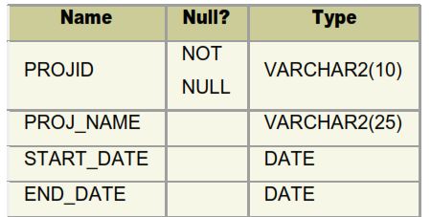

**CREATE TABLE Project(PROJID NVARCHAR(10)NOT NULL,PROJ_NAME NVARCHAR(25),"START_DATE" DATE,"END_DATE" DATE);**

1. Insert Records into Project Table as deemed necessary and relevant

**insert project values('A','aaa','10/3/2023','12/4/2023');**

**insert project values(2,'ccc','2023/04/25','2023/05/24');**

**insert project values(3,'bbb','2023/03/14','2023/04/15');**